# Advance Devops Experiment 1

**Aim:-** To understand the benefits of Cloud infrastructure and Setup AWS Cloud9 IDE, Launch AWS Cloud9 IDE and Perform Collaboration Demonstration

**LO : 1 –** To understand the fundamentals of Cloud Computing and be fully proficient with Cloud based DevOps solution deployment options to meet the business requirements

**Theory:-**

**CLOUD**

"The cloud" refers to servers that are accessed over the Internet, and the software and databases that run on those servers. Cloud servers are located in [data centers](https://www.cloudflare.com/learning/cdn/glossary/data-center/) all over the world. By using cloud computing, users and companies do not have to manage physical servers themselves or run software applications on their own machines.The cloud enables users to access the same files and applications from almost any device, because the computing and storage takes place on servers in a data center, instead of locally on the user device.

**CLOUD COMPUTING**

Cloud computing is a general term for anything that involves delivering hosted services over the internet. These services are divided into three main categories or types of cloud computing: infrastructure as a service ([IaaS](https://www.techtarget.com/searchcloudcomputing/definition/Infrastructure-as-a-Service-IaaS)), platform as a service ([PaaS](https://www.techtarget.com/searchcloudcomputing/definition/Platform-as-a-Service-PaaS)) and software as a service ([SaaS](https://www.techtarget.com/searchcloudcomputing/definition/Software-as-a-Service)).A cloud can be private or public. A public cloud sells services to anyone on the internet.

**TYPES OF CLOUD**

## **Public Cloud**

Public cloud is **open to all** to store and access information via the Internet using the pay-per-usage method.In public cloud, computing resources are managed and operated by the Cloud Service Provider (CSP).

## **Private Cloud**

Private cloud is also known as an **internal cloud** or **corporate cloud**. It is used by organizations to build and manage their own data centers internally or by the third party. It can be deployed using Opensource tools such as Openstack and Eucalyptus.

Based on the location and management, National Institute of Standards and Technology (NIST) divide private cloud into the following two parts-

* On-premise private cloud
* Outsourced private cloud

## **Hybrid Cloud**

Hybrid Cloud is a combination of the public cloud and the private cloud. we can say:

**Hybrid Cloud = Public Cloud + Private Cloud**

Hybrid cloud is partially secure because the services which are running on the public cloud can be accessed by anyone, while the services which are running on a private cloud can be accessed only by the organization's users.

**CLOUD SERVICE PROVIDERS**

* Amazon Web Services (AWS)
* Microsoft Azure.
* Google Cloud.
* Alibaba Cloud.
* IBM Cloud.
* Oracle.
* Salesforce.
* SAP.

**Cloud Service Models**

## **Infrastructure as a Service (IaaS)**

IaaS is also known as **Hardware as a Service (HaaS)**. It is a computing infrastructure managed over the internet. The main advantage of using IaaS is that it helps users to avoid the cost and complexity of purchasing and managing the physical servers.

### **Characteristics of IaaS**

There are the following characteristics of IaaS -

* Resources are available as a service
* Services are highly scalable
* Dynamic and flexible
* GUI and API-based access
* Automated administrative tasks

## **Platform as a Service (PaaS)**

PaaS cloud computing platform is created for the programmer to develop, test, run, and manage the applications.

### **Characteristics of PaaS**

### There are the following characteristics of PaaS -

* Accessible to various users via the same development application.
* Integrates with web services and databases.
* Builds on virtualization technology, so resources can easily be scaled up or down as per the organization's need.
* Support multiple languages and frameworks.
* Provides an ability to "**Auto-scale**".

## **Software as a Service (SaaS)**

SaaS is also known as "**on-demand software**". It is a software in which the applications are hosted by a cloud service provider. Users can access these applications with the help of internet connection and web browser.

### **Characteristics of SaaS**

There are the following characteristics of SaaS -

* Managed from a central location
* Hosted on a remote server
* Accessible over the internet
* Users are not responsible for hardware and software updates. Updates are applied automatically.
* The services are purchased on the pay-as-per-use basis

# FEATURES OF CLOUD COMPUTING

Cloud computing is becoming popular day by day. Continuous business expansion and growth requires huge computational power and large-scale data storage systems. Cloud computing can help organizations expand and securely move data from physical locations to the 'cloud' that can be accessed anywhere.

### **1. RESOURCES POOLING**

Resource pooling is one of the essential features of cloud computing. Resource pooling means that a cloud service provider can share resources among multiple clients, each providing a different set of services according to their needs. It is a multi-client strategy that can be applied to data storage, processing and bandwidth-delivered services. The administration process of allocating resources in real-time does not conflict with the client's experience.

### **2. ON-DEMAND SELF-SERVICE**

It is one of the important and essential features of cloud computing. This enables the client to continuously monitor server uptime, capabilities and allocated network storage. This is a fundamental feature of cloud computing, and a customer can also control the computing capabilities according to their needs.

### **3. EASY MAINTENANCE**

This is one of the best cloud features. Servers are easily maintained, and downtime is minimal or sometimes zero. Cloud computing powered resources often undergo several updates to optimize their capabilities and potential. Updates are more viable with devices and perform faster than previous versions.

### **4. SCALABILITY AND RAPID ELASTICITY**

A key feature and advantage of cloud computing is its rapid scalability. This cloud feature enables cost-effective handling of workloads that require a large number of servers but only for a short period. Many customers have workloads that can be run very cost-effectively due to the rapid scalability of cloud computing.

### **5. ECONOMICAL**

This cloud feature helps in reducing the IT expenditure of the organizations. In cloud computing, clients need to pay the administration for the space used by them. There is no cover-up or additional charges that need to be paid. Administration is economical, and more often than not, some space is allocated for free.

## **USES OF DEVOPS**

### **MAXIMIZES EFFICIENCY WITH AUTOMATION**

The late DevOps authority [Robert Stroud said DevOps is all about "fueling business transformation"](https://blog.xebialabs.com/2018/09/05/in-honor-of-robert-stroud-a-devops-luminary-amazing-colleague-and-good-friend/) that encompasses people, process and culture change. The most effective strategies for DevOps transformation focus on structural improvements that build community. A successful DevOps initiative requires a culture—or mindset—change that brings greater collaboration between multiple teams—product, engineering, security, IT, operations and so on—as well as automation to better achieve business goals.

What kind of tangible benefits can DevOps bring? By [managing engineering processes end to end](https://www.guru99.com/agile-vs-devops.html), DevOps emphasizes deploying software more often, in a reliable and secure way through automation.

### **OPTIMIZES THE ENTIRE BUSINESS**

System architect [Patrick Debois, best known as the creator of the DevOps movement, says](https://www.linux.com/tutorials/what-devops-patrick-debois-explains/) the biggest advantage of DevOps is the insight it provides. It forces organizations to "optimize for the whole system," not just IT siloes, to improve the business as a whole. In other words, be more adaptive and data-driven for alignment with customer and business needs.

**USE OF ADVANCED DEVOPS**

1. Provisioning, configuring and managing the infrastructure on AWS, Azure, and GCP for our customers
2. Using Docker containers for continuous apps delivery
3. Using rolling updates to ensure an uninterrupted end-user experience
4. Using Kubernetes for fast and reliable container management
5. Using Terraform for state-of-the-art infrastructure orchestration
6. Using automated unit tests to provide in-depth code review and QA
7. Using Jenkins, Gitlab CI and CircleCI for building continuous software delivery pipelines
8. Using Prometheus & Grafana, Sumologic and ELK Stack for in-depth service monitoring and logging
9. 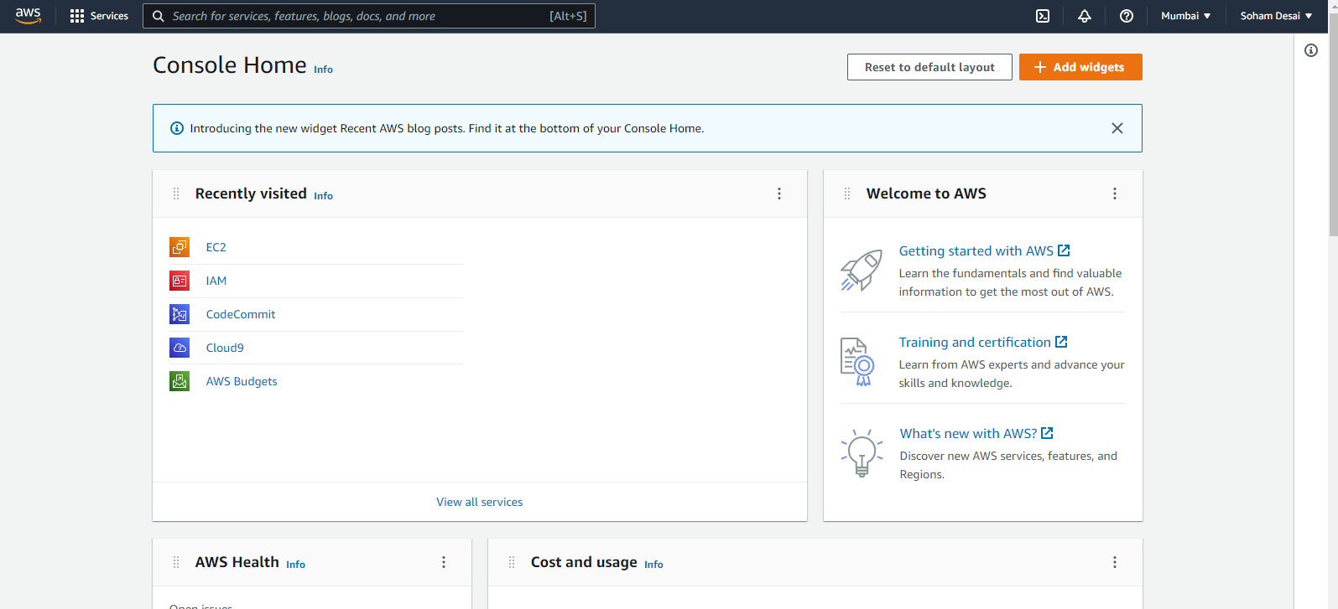Login with your AWS account
10. 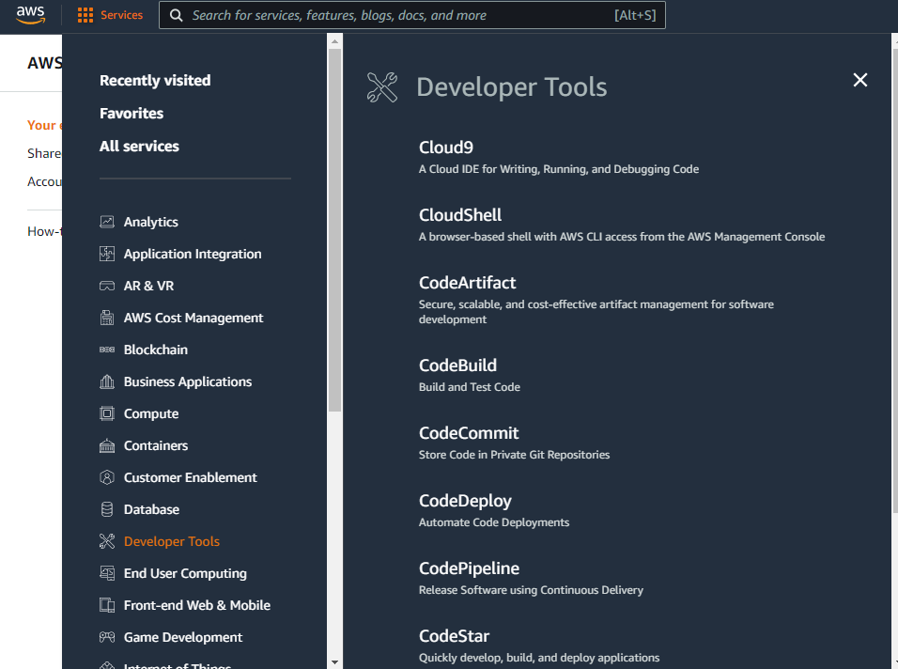Navigate to Cloud9 Service from Developer tools section as shown below
11. 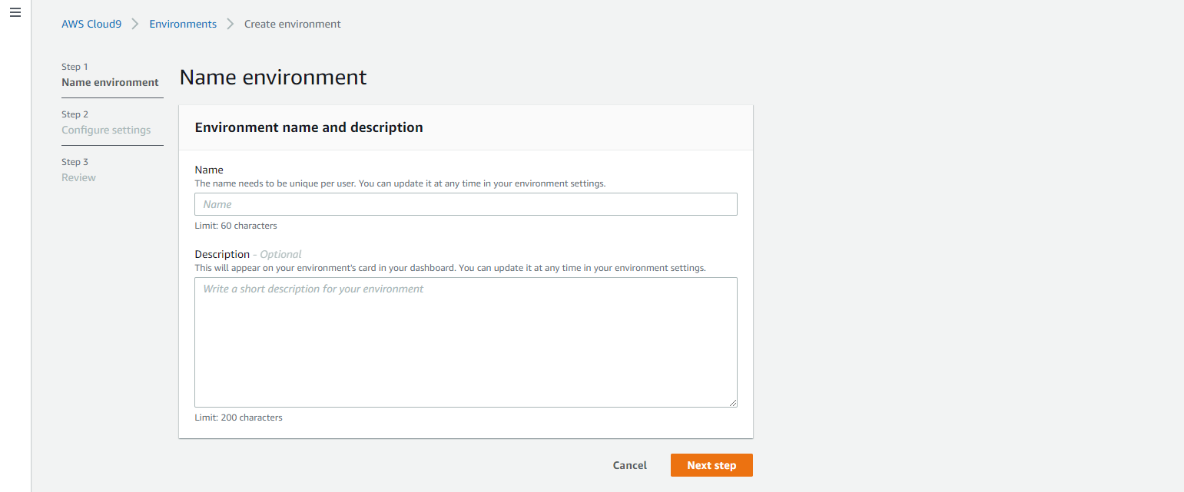Click on create environment
12. 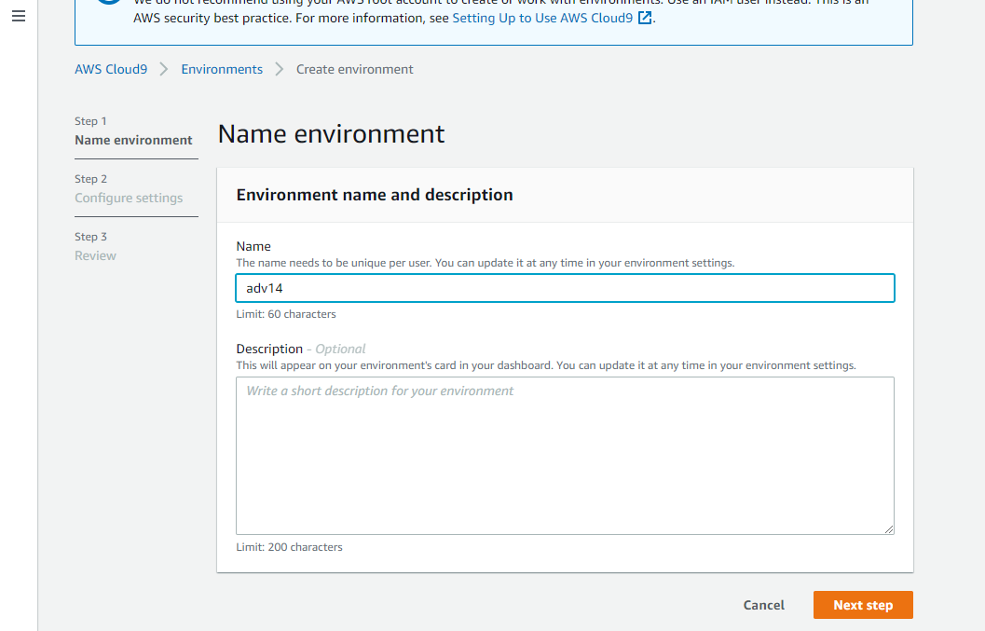Provide name for environment (adv14), click on next
13. 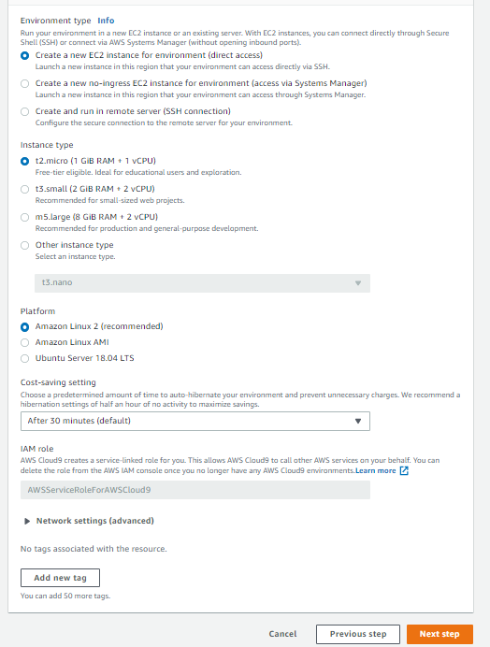Keep all the default settings as shown below
14. 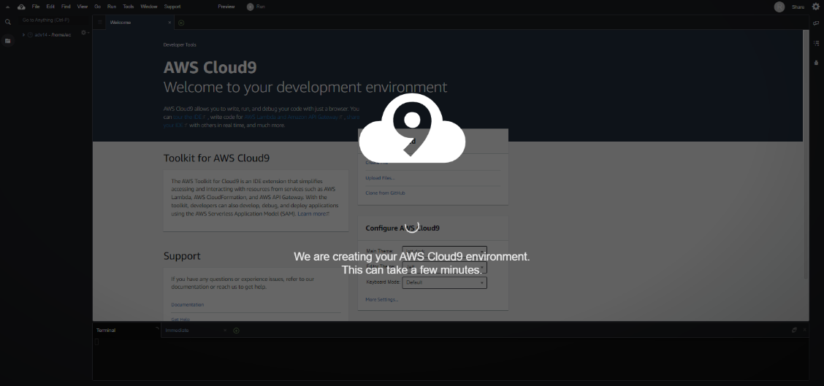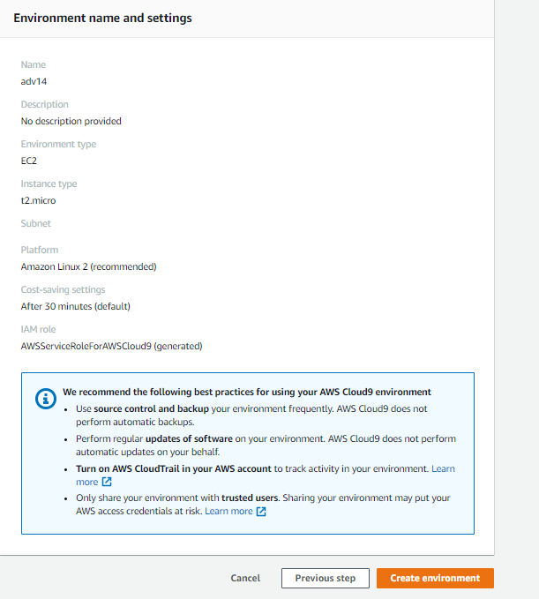Review the environment and settings and click on create environment
15. 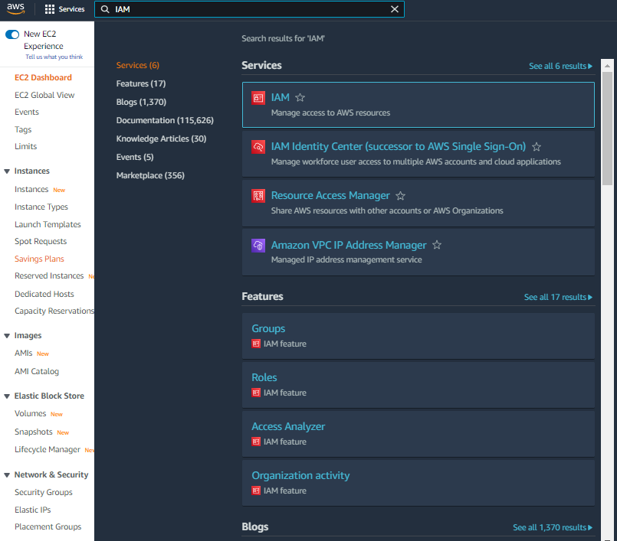Till that time open IAM identity and access management in order to add user in the other tab
16. Add user provide with auto generated password and click on next permission tab

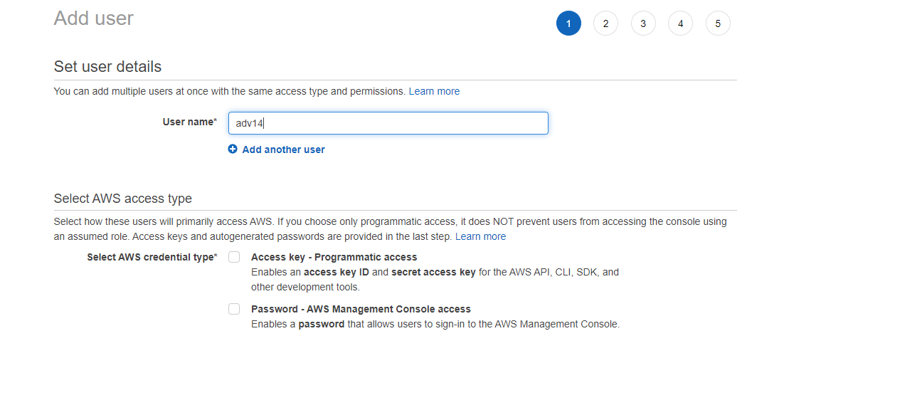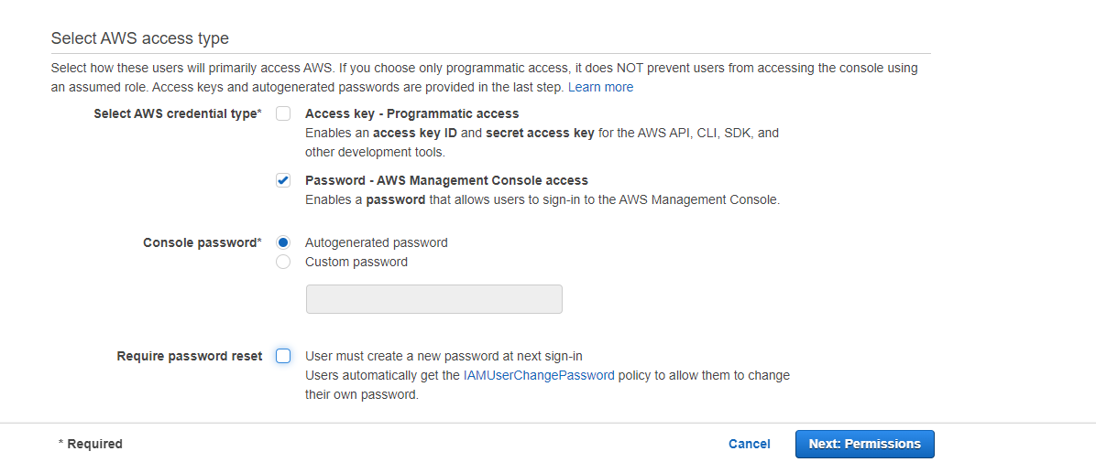

1. Click in create group

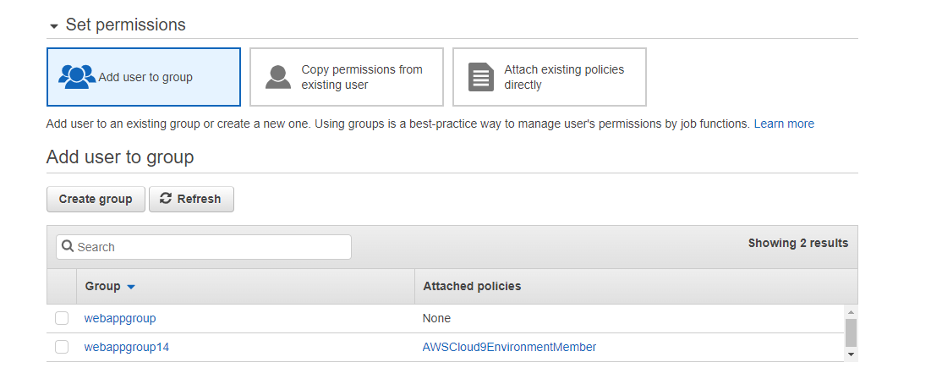

1. Provide group name and create group by selecting correct policies 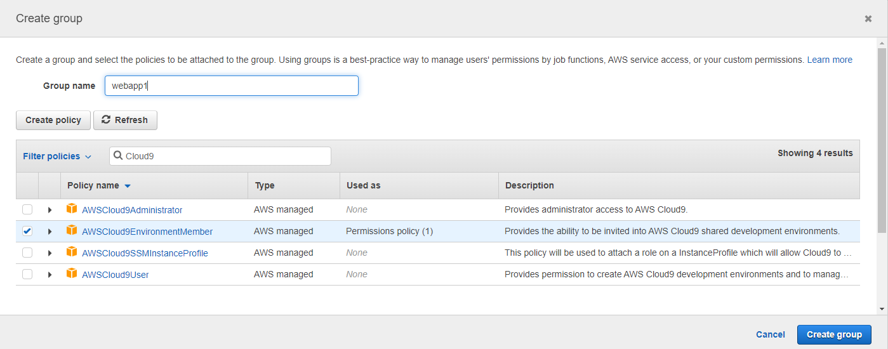
2. After that group is created click on next if you want to provide tag else click in review for user setting and click on create user as shown below

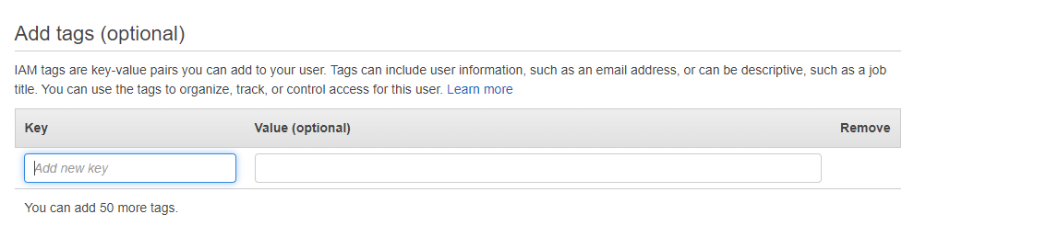

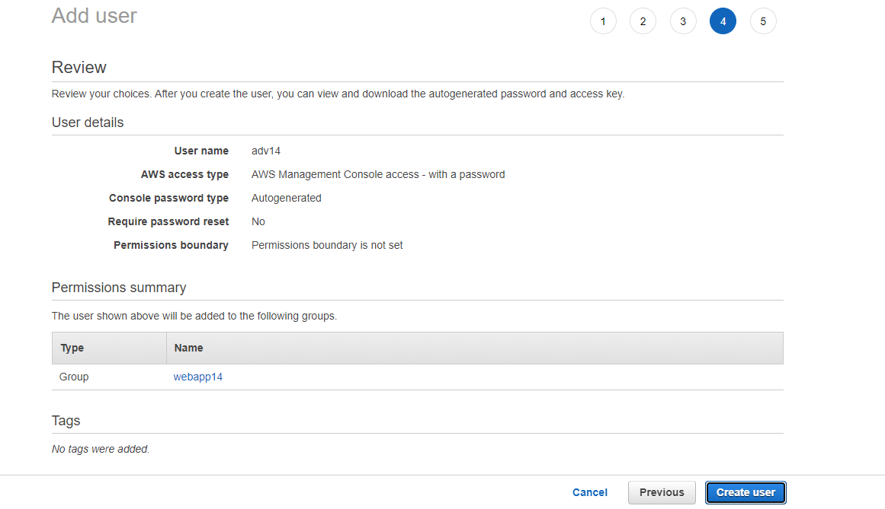

1. 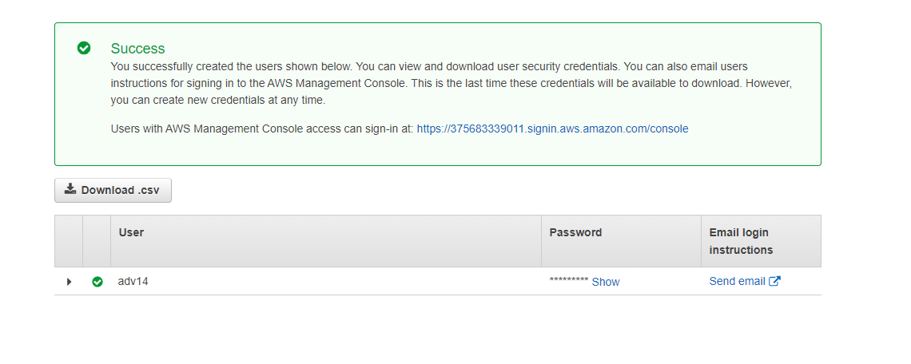Now create a user
2. Now move towards Cloud9 IDE environment tab
3. 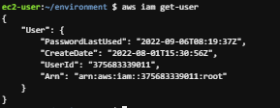at bottom side Cloud9 IDE use AWS CLI for command operations: git version, IAM user details and so on



1. 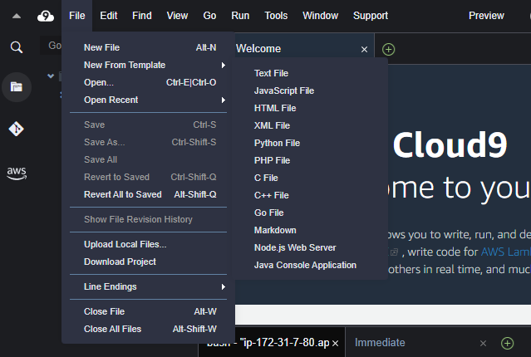Setup collaborative environment.

1. Edit and Save HTML file

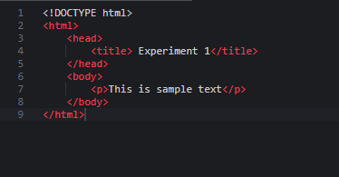

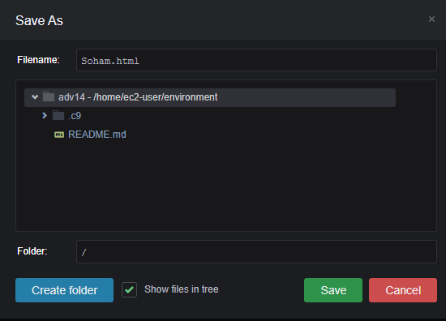

1. Now in order to share the created HTML file to collaborate with other members of your team click on share option and user name which you created in IAM before into invite members and enable permissions as RW and click on done

Click ok on security warnings

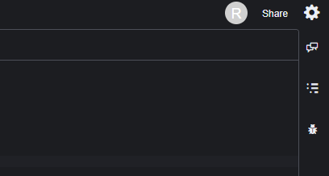

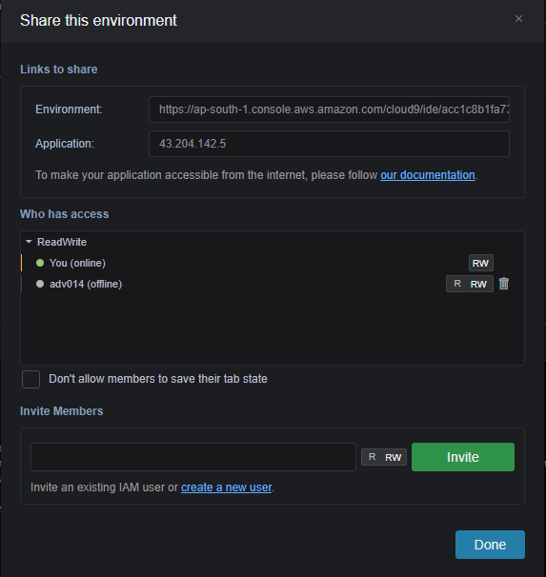

1. Open browser’s incognito window and login with IAM user which you configured before

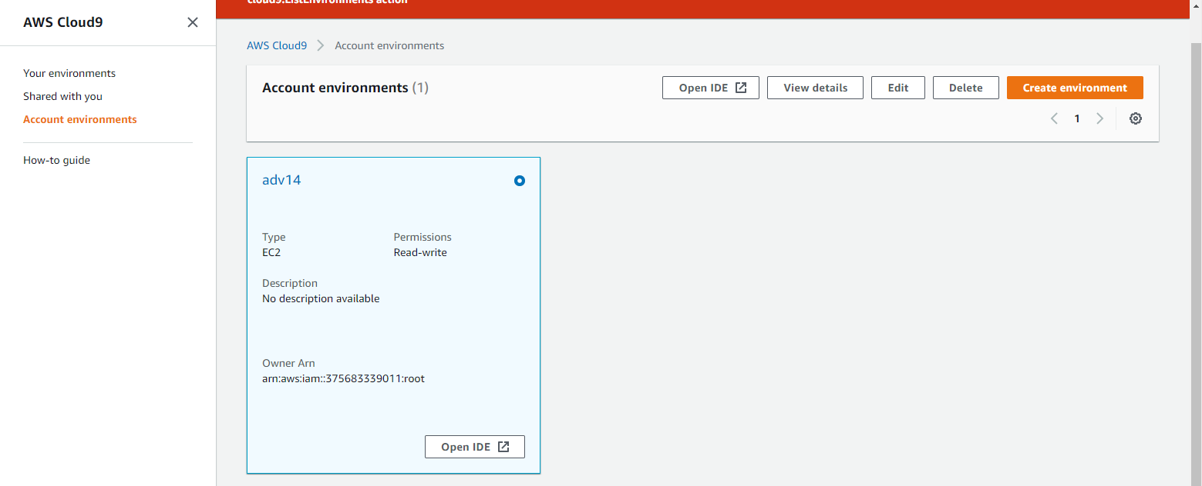

1. Click on Open IDE you will get same interface as your other member have to collab in real time.

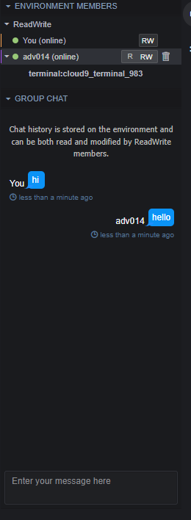Here both members are in on team and can modify the same file or can do group chat as below

